Bengt Thorsson and Johan Rockberg to join Atlas Antibodies’ Board of Directors

We are pleased to announce the election of Bengt Thorsson and Johan Rockberg to Atlas Antibodies’ Board of Directors, following the AGM on May 23, 2025. Åsa Riisberg has been re-elected as Chair of the Board and Catarina Flyborg, Gavin Wood, Christian Eberle and Louise Kores have been re-elected as board members. We thank Mathias Uhlén and Lotta Ljungqvist for their years of dedicated service and valuable contributions as they step down from the Board. The size of the Board remains unchanged.
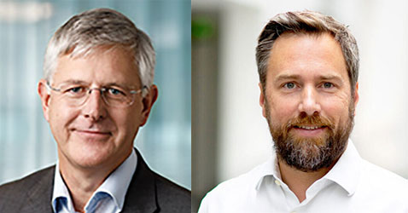
May 2025
“It’s a great pleasure to welcome Bengt Thorsson and Johan Rockberg to the Board of Directors of Atlas Antibodies,” says Åsa Riisberg, Chair of the Board. “Their diverse and complementary backgrounds will bring both strategic insight and scientific depth to the board. I’m confident they will make significant contributions to the continued growth and success of our business.”
Bengt Thorsson brings a distinguished track record in executive leadership role at global companies such as Scania, Dometic and most recently as the CEO of Permobil. He also brings deep expertise in strategic development, international market expansion, and operational excellence along with a global perspective and proven ability to scale complex businesses.
Johan Rockberg is a professor in Antibody Technology at The Swedish Royal Institute of Technology and member of the Swedish Young Academy. He has experience from both academia and the international biotech industry and in 2024 he was awarded the “Biotech Builders Award” for his contributions to the field. Rockberg has founded and been engaged in several biotech start-ups, including Biolamina, Alligator Biosciences, Affibody, SpiberTechnologies and Abclon.

